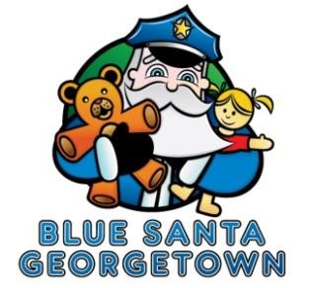
Friends of Blue Santa
Sponsorship Opportunities

Individual or Business Name: ____________________________________________ Address: ______________________________ City/State/Zip: ______________________ Contact Name: ______________________________ Phone: ___________________

Email Address: ________________________________________

Sponsorship Levels
 Bronze |  | $150 - $500 | $ __________
 Silver |  | $501 - $1,000 | $ __________
 Gold |  | $1,001 - $2,500 | $ __________
 Platinum |  | $2,501 - $5,000 | $ __________
 |  | Donation Total | $ __________

Please make your check payable to ‘CPAAA - Blue Santa’ and indicate ‘Friends of Blue Santa’ in the memo area of your check. Mail your check to the contact address shown below. We regret that we cannot accept credit cards at this time.
CPAAA Blue Santa
C/O Georgetown Police Department
3500 D B Wood Road
Georgetown, Texas 78628

Please check here if the sponsorship Level is an In-Kind donation □
Please indicate the In-Kind item(s) donated _____________________________________

Signature: ______________________________________ Title: ______________________
Name Printed: ___________________________________ Date: _____________________

Thank you for being a Friend! A tax donation receipt will be sent to you.

